|  |  |
| --- | --- |
| **Ex. No. 3** | **Responsive Web page using HTML5 and CSS3** |
| **Date of Exercise** | **26.07.23** |

**Aim**

To Create a responsive web page using HTML5 and CSS3 to conform the html and css features.

**Description**

* CSS stands for Cascading Style Sheets, CSS describes how HTML elements are to be displayed on screen, paper, or in other media.
* p is a selector in CSS (it points to the HTML element you want to style: <p>). color is a property, and red is the property value, text-align is a property, and center is the property value.
* The id selector uses the id attribute of an HTML element to select a specific element.
* The class selector selects HTML elements with a specific class attribute. To select elements with a specific class, write a period (.) character.
* The universal selector (*) selects all HTML elements on the page. There are three ways of inserting a style sheet are External CSS, Internal CSS and Inline CSS
* The CSS background properties are used to add background effects for elements
* The background-color property specifies the background color of an element. The background-image property specifies an image to use as the background of an element.
* By default, the background-image property repeats an image both horizontally and vertically. If the image above is repeated only horizontally (background-repeat: repeat-x;)
* The background-position property is used to specify the position of the background image.

**Program**

**HTML:**

<!DOCTYPE html>

<html lang="en">

<head>

<meta charset="UTF-8">

<meta name="viewport" content="width=device-width, initial-scale=1.0">

<title>Responsive Web Page</title>

<link rel="stylesheet" href="ex3.css">

</head>

<body>

<h1 class = "head">Mircosoft</h1>

<img src = "https://www.bleepstatic.com/content/hl-images/2021/03/18/microsoft-fire.jpg">

<h3 class = "u">About Us</h3>

<p id = "about">Microsoft Corporation is an American multinational technology corporation headquartered in Redmond, Washington. Microsoft's

best-known software products are the Windows line of operating systems, the Microsoft 365 suite of productivity applications, and the

Internet Explorer and Edge web browsers.Microsoft is the largest vendor of computer software in the world. It is also a leading provider

of cloud computing services, video games, computer and gaming hardware, search and other online services. Microsoft's corporate headquarters

is located in Redmond, Wash., and it has offices in more than 60 countries. Company origins Harvard University classmates Bill Gates and

Paul Allen started Microsoft in 1975 to develop a compiler for the Altair 8800, a very primitive early computer. Gates contacted the manufacturer

Micro Instrumentation and Telemetry Systems (MITS) and offered to write a program for the new computer. Gates and Allen created an interpreter for

BASIC -- which was then a mainframe programming language -- to use with the Altair. MITS hired Gates and Allen in 1975. But by 1976, they left to

devote more time to their own fledgling company, Microsoft, which they incorporated in 1981. That year, the company was contracted by IBM to develop

an operating system for IBM's personal computer. Called PC-DOS by IBM, Microsoft also marketed its own version, MS-DOS (Microsoft Disk Operating System).

The early 1980s saw both IBM's and Microsoft's fortunes soar.Microsoft developed a graphical interface that ran on top of DOS called Interface Manager,

later renamed Windows on its release in 1985. This was inspired by the same Xerox PARC research project that Apple used to move an arrow across a graphical desktop.</p>

<div class = 'b1'>

<p class='top' style = "padding:20px; opacity:50%;">Microsoft products</p>

</div>

<div class="b2">

<p class='bottom' style = "padding:20px; opacity:50%;">Microsoft Windows</p>

</div>

<div class = "b3">

<p class='top' style = "padding:20px; opacity:50%;">Microsoft Accessories</p>

</div>

<div class="bo">

<h2 style = "padding: 50px; padding-top: 20px; font-size: x-large;">Mircosoft Work Environment</h2>

<p style = "text-align: justify; padding: 50px; padding-top: 20px; font-size: x-large;">The majority of employees at Microsoft believe the environment at Microsoft is positive. Most Participants believe the pace of work at Microsoft is comfortably fast.

About 55% of the employees at Microsoft work 8 hours or less, while 7% of them have an extremely long day - longer than twelve hours.</p>

</div>

<div class="bo1">

</div>

<div class = "bo2">

</div>

<div class ="bo">

<h2 style = "padding: 50px; padding-top: 20px; font-size: x-large;">Microsoft Growth Rate</h2>

<p style = "text-align: justify; padding: 50px; padding-top: 20px; font-size: x-large;">Microsoft Corporation is one of the largest broad-based technology providers in the world. The company dominates the PC software market with more than 80% of the market share for operating systems.

The company's Microsoft 365 application suite is one of the most popular productivity software globally. It is also now one of the two public cloud providers that can deliver a wide variety of

infrastructure-as-a-service (IaaS) and platform-as-a-service (PaaS) solutions at scale. Microsoft's products include operating systems, cross-device productivity applications, server applications,

business solution applications, desktop and server management tools, software development tools and video games. </p>

</div>

</body>

</html>

**CSS:**

.head{

text-align: center;

background-color: blue;

}

img{

width : "100%";

height: "500";

}

#about{

background-color: antiquewhite;

margin:0px;

}

.u{

text-align: center;

background-color: antiquewhite;

margin: 0px;

}

.b1{

width:33.33%;

height:200px;

background-image: url(mic_pr.jpg);

background-size:cover;

background-position: center;

background-repeat: no repeat;

float:left;

}

.b2{

width:33.33%;

height:200px;

background-image: url(Windows.jpg);

background-size:cover;

background-position: center;

background-repeat: no repeat;

float:left;

}

.b3{

width:33.33%;

height:200px;

background-image: url(micro_acc.jpg);

background-size:cover;

background-position: center;

background-repeat: no repeat;

float:left;

}

.top{

position: relative;

top: 7em;

}

.bottom{

position: relative;

top: -1em;

}

p{

background-color: rgb(247, 240, 240);

opacity: 100%;

padding: 0 auto;

}

.bo{

background-color:rgb(174, 136, 86);

width:50%;

float:left;

height:300px;

}

.bo1{

background-image: url(work.jpg);

background-size:cover;

background-position: center;

background-repeat: no repeat;

float:left;

width:50%;

height:300px;

}

.bo2{

background-image: url(microsoft.jpg);

background-size:cover;

background-position: center;

background-repeat: no repeat;

float:left;

width:50%;

height:300px;

}

**Output**

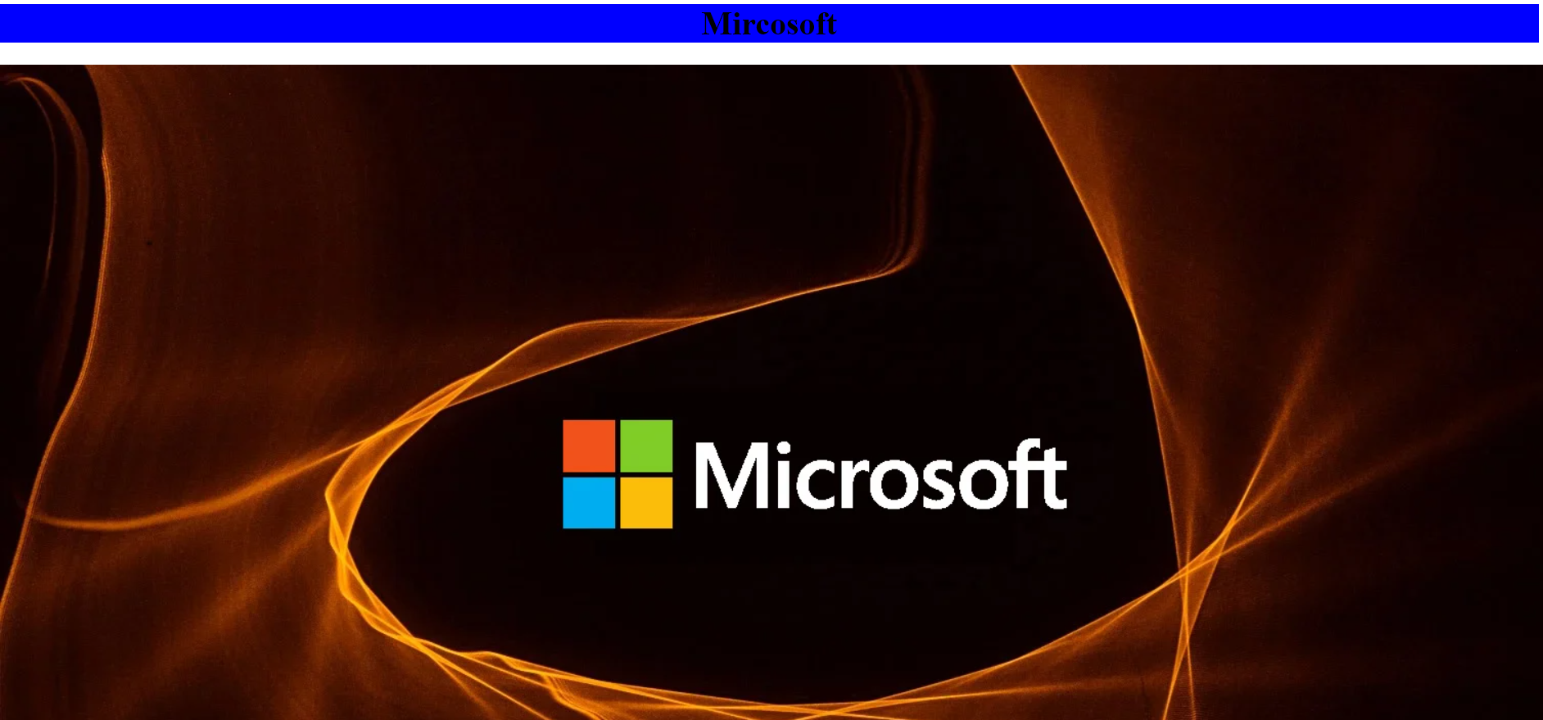

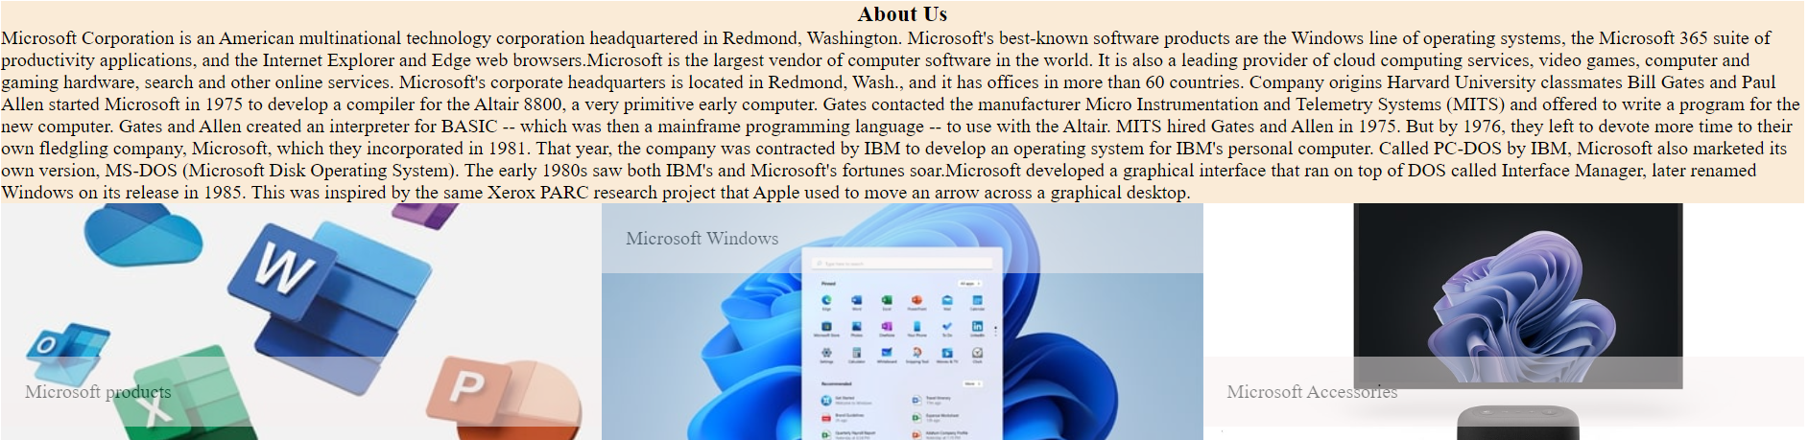

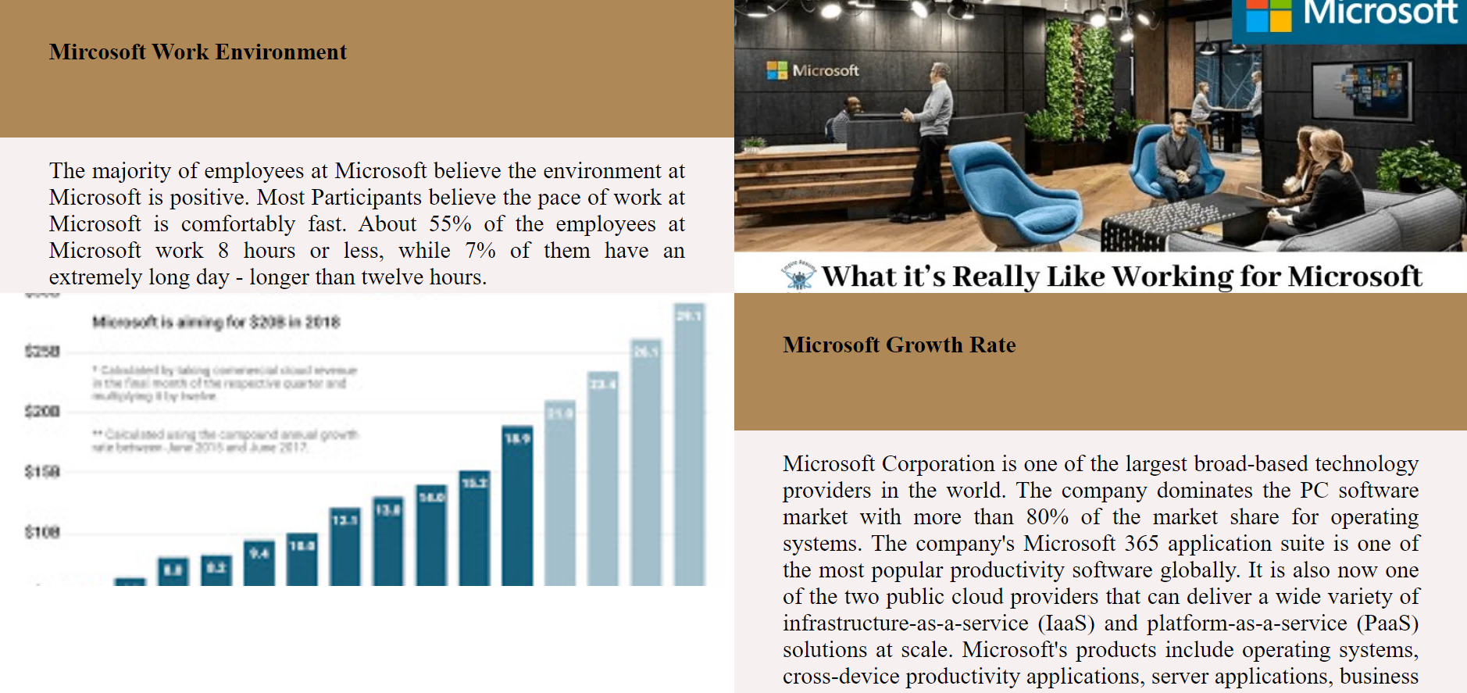

**Result**

The program is executed successfully and the program output is displayed in the web browser.